Traversal Depth Across the AdS/CFT Domain
  - From the Circle-to-Spring Argument to Positive Holographic Evolution
Joseph Shields
Working paper · 28 July 2026
A completed traversal cannot be erased merely by identifying its endpoint with its origin.

Abstract
The circle-to-spring argument begins with a deliberately weak claim: after a system completes A → B → C, its return to A is the next occurrence of A, not the first occurrence restored. The circular picture is obtained only by suppressing the depth created by traversal. This paper carries that same claim into holographic Hamilton–Jacobi evolution. Boundary-to-bulk reconstruction may move opposite to the conventionally outward radial vector field, but a negative geometric direction is not negative completed evolution. Once the boundary is marked as the origin, the sign-definite decrease can be represented exactly by a positive accumulated variable. The AdS/CFT trajectory therefore has the same structure as the spring: its projection may repeat a radial label or Jacobi-space configuration, while its origin-marked traversal remains ordered.

1. The Minimal Claim
The argument begins before any specialised geometric or holographic machinery is introduced. If a system passes through an ordered sequence and returns to a label already occupied, the completed passage remains part of the resulting state.

Direct statement:
You went around once. Even if you are back at A, this is now the next occurrence of A.

Mathematical statement:
A₀ → B₀ → C₀ → A₁, with A₁ ≠ A₀ as an occurrence.
The subscript records no additional physical assumption. It retains only the order already required to complete the traversal. The endpoint may share the same projected label while remaining distinct as an occurrence.

2. The Circle Becomes a Spring
A flat loop is normally written
A → B → C → A.
But the final A is reached only after B and C. Preserving that order gives
A₀ → B₀ → C₀ → A₁ → B₁ → C₁ → A₂ → ⋯
The repeating A–B–C pattern remains, but each completed circuit creates depth. B is no longer merely a point between A and C. B is the traversal that separates one occurrence of the pattern from the next. Flatten the depth and the structure looks circular. Retain it and the circle opens into a spring.
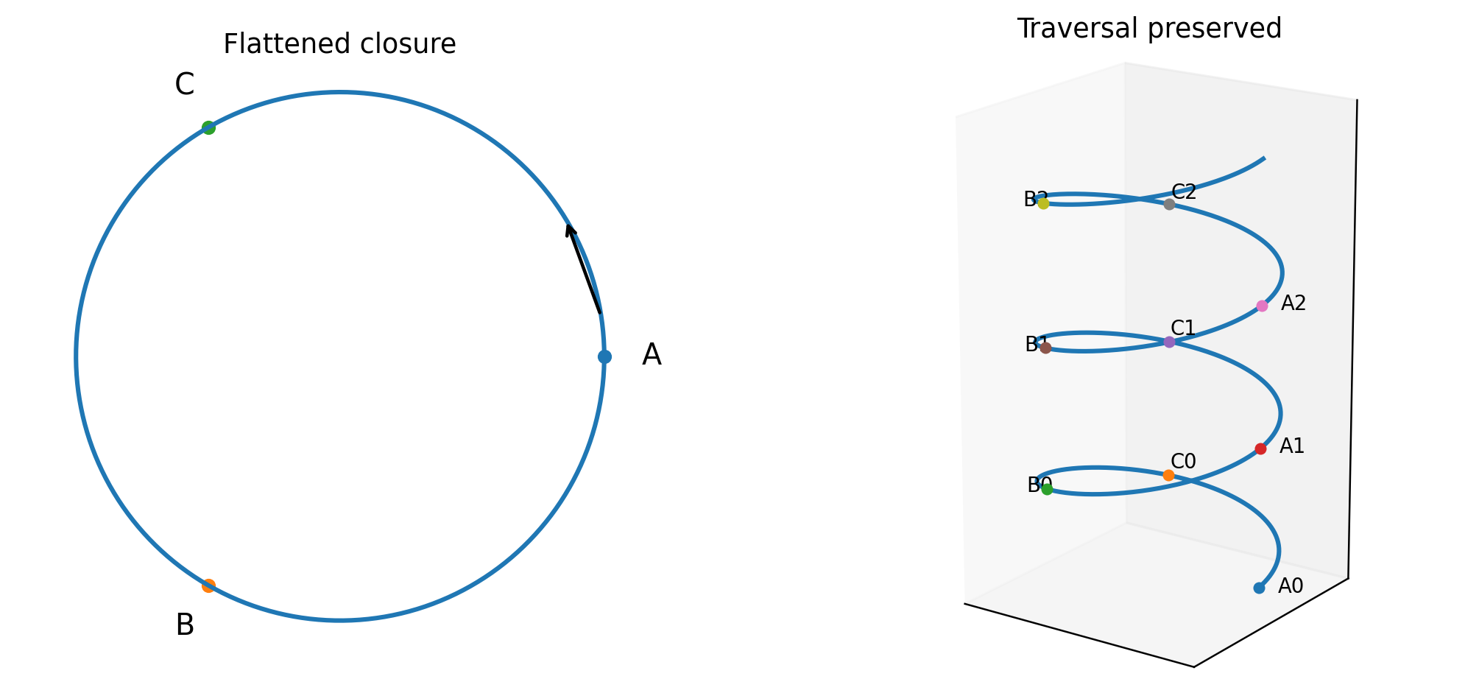
Figure 1. The same cyclic relation with traversal suppressed and with traversal retained.

3. Projection and Lift
Let q(s) denote the state seen in the ordinary geometric or configuration-space description. Introduce a history variable E(s) that records completed traversal, with
dE/ds = κ(s), κ(s) > 0.
The complete state is then not q(s) alone but the lifted state
Q̃(s) = (q(s), E(s)).
The projection forgets traversal depth:
π(Q̃(s)) = q(s).
A projected recurrence can therefore satisfy
q(s₁) = q(s₀)
while the complete states remain different:
Q̃(s₁) ≠ Q̃(s₀), because E(s₁) − E(s₀) = ∫ₛ₀ˢ¹ κ(u)du > 0.
This is the general circle-to-spring statement. A base description may close or recur. A strictly increasing history coordinate cannot close merely because the projection does.

4. Entering the AdS/CFT Domain
In the Hamilton–Jacobi treatment of AdS/CFT, the bulk radial coordinate acts as an evolution parameter. Boundary data are supplied on a radial slice and used to reconstruct the bulk. The usual first-order Hamilton–Jacobi vector field is conventionally written in the outward radial direction.
Let q denote the collection of induced fields on a radial slice—metric data, scalar fields and any other variables retained in the truncation. Write the conventional outward flow as
dq/dr = V_HJ(q).
Now mark the boundary as the operational origin. If r = r_b at the boundary, define an inward parameter
s = r_b − r, so that s = 0 at the boundary and ds = −dr.
The same geometric trajectory, performed from boundary to bulk, obeys
dq/ds = −V_HJ(q).
This minus sign does not say that the reconstruction un-happens. It says that the operation proceeds opposite to the conventionally outward radial orientation. The boundary is A, the radial reconstruction is B, and the reached bulk configuration is C. B gives the AdS/CFT trajectory depth because it is the operation that carries the boundary data into the bulk.

5. From Negative Direction to Positive Completed Evolution
Suppose a Hamilton–Jacobi quantity W(q(s)) decreases along the boundary-originated branch:
dW/ds = −K(q(s)), K(q) ≥ 0.
Integrating from the marked boundary origin gives
W(s) − W(0) = −∫₀ˢ K(q(u))du.
The negative integral records direction in the Hamilton–Jacobi landscape. It is not a negative amount of evolution. Define the positive completed evolution
E(s) := ∫₀ˢ K(q(u))du = W(0) − W(s) ≥ 0.
Then
dE/ds = K(q(s)) ≥ 0.
Nothing has been discarded. The minus sign has been moved from the amount completed into the orientation of the base trajectory. The exact same branch can therefore be written in two complementary ways:
geometric direction: dW/ds = −K,
completed evolution: dE/ds = +K.
This is the AdS/CFT version of opening the circle into a spring. The radial coordinate may run inward or a Jacobi-space quantity may decrease, while the traversal performed from the marked origin accumulates positively.

6. The Holographic Spring
The lifted holographic state is
Q̃(s) = (q(s), E(s)).
The ordinary Hamilton–Jacobi description sees q(s). Arrow of Time Operation Integrals retain the origin, the orientation and E(s). If the projected trajectory reaches the same Jacobi-space configuration twice,
q(s₁) = q(s₀),
the complete origin-marked histories still satisfy
Q̃(s₁) ≠ Q̃(s₀) whenever ∫ₛ₀ˢ¹ K(q(u))du > 0.
The projection has returned to A. The full operation has reached A after traversal. In the same notation used for the circle-to-spring argument,
A₀ → B₀ → C₀ → A₁
becomes, in holographic language,
(q₀,E₀) → radial reconstruction → (q₁,E₁), with E₁ > E₀.
Even when q₁ is identified with q₀ by a projection, symmetry or recurrence, the lifted state retains the completed operation. The holographic flow is therefore helical in the same structural sense: the configuration may repeat across the width, while positive evolution advances through the depth.

7. Boundary Beta Functions and the Rate of Depth
In a standard scalar holographic flow, the positive rate can be expressed through the norm of the boundary beta function. Schematically, with a positive-definite scalar target-space metric Gₐᵦ,
K = Gₐᵦ βᵃβᵇ ≥ 0.
Hence
E(s) = ∫₀ˢ Gₐᵦ βᵃβᵇ du.
This gives B a precise mathematical depth. The radial passage is not an empty connector between two endpoint descriptions. Its depth is the accumulated norm of the flow performed between them. At a fixed point, βᵃ = 0 and the coupling-space contribution does not run. Away from a fixed point, every nonzero beta-function norm contributes positively to completed holographic evolution.

8. The Common Principle
Gödel-type closure and holographic radial reversal initially look like different problems. One concerns a closed timelike curve; the other concerns reconstruction across the AdS/CFT domain. Their logical structure is nevertheless the same: an endpoint or projected description can suppress the operation that produced it.
Structure | Projection says | Traversal-preserving lift says
Circle / Gödel path | A returns to A | A₀ reaches A₁ after B and C
AdS/CFT radial flow | The same trajectory is reparameterized | Boundary origin fixes the performed direction
Negative HJ change | W decreases | E = W(0) − W(s) increases
Configuration recurrence | q(s₁) = q(s₀) | (q,E)(s₁) ≠ (q,E)(s₀) when E increased

The common rule is:
Projection may repeat an endpoint. Traversal preserves the operation.
Or in the language of the spring:
Repetition preserves the shape; positive evolution gives it depth.

9. A Compact Theorem
Theorem — Positive Traversal Lift
Let q : [0,S] → X be a trajectory in a base state space, and let K : X → [0,∞) be continuous. Define
E(s) = ∫₀ˢ K(q(u))du, Q̃(s) = (q(s),E(s)).
If q(s₁) = q(s₀) for s₁ > s₀ and K(q(u)) is positive on a subset of [s₀,s₁] of nonzero measure, then
Q̃(s₁) ≠ Q̃(s₀).
Proof. Since K ≥ 0 and is positive over a nonzero part of the interval,
E(s₁) − E(s₀) = ∫ₛ₀ˢ¹ K(q(u))du > 0.
Thus the history components differ even though the projected base states agree. Therefore the lifted states are unequal. ∎
For the circle, E may be turn number, elapsed proper time or any strictly increasing traversal record. For holographic Hamilton–Jacobi evolution, E is the positive accumulated quantity obtained from the sign-definite branch. The theorem is the same in both domains.

10. Conclusion
The connection from the circle-to-spring argument to AdS/CFT is direct. A closed or reversed-looking geometric description does not imply that completed evolution is negative or erased. In Gödel’s universe, returning to the same projected event does not remove the traversal that brought the observer there. In holographic reconstruction, moving opposite to the outward radial Hamilton–Jacobi field does not make the boundary-to-bulk operation run backward. It gives the base trajectory a negative orientation while the completed evolution accumulates positively.
The complete flow is therefore:
mark the origin → preserve the direction → perform the traversal → accumulate positive depth → distinguish the returned projection from the completed history.
In formal terms, the lifted state (q,E) retains both the projected configuration and the positive depth accumulated by reaching it. The projection may recur, but the completed history does not thereby vanish.

References
1. Gödel, K. (1949). “An Example of a New Type of Cosmological Solutions of Einstein’s Field Equations of Gravitation.” Reviews of Modern Physics 21, 447–450.
2. Maldacena, J. M. (1998). “The Large N Limit of Superconformal Field Theories and Supergravity.” Advances in Theoretical and Mathematical Physics 2, 231–252.
3. Witten, E. (1998). “Anti-de Sitter Space and Holography.” Advances in Theoretical and Mathematical Physics 2, 253–291.
4. de Boer, J., Verlinde, E., and Verlinde, H. (2000). “On the Holographic Renormalization Group.” Journal of High Energy Physics 08, 003.
5. Shields, J. (2026). “The Depth of Traversal: Why a Closed Timelike Curve Does Not Reverse the Order of Experience.” Working paper.
6. Shields, J. (2026). “Origin-Oriented Hamilton–Jacobi Flow and Observer-Preserving Time: Arrow of Time Operation Integrals, Positive Holographic Evolution, and Observer-Lifted Nonclosure.” Working paper.

